

VERTICAL WAY AROUND

12 month – 35 countries – more then 70 ski areas!!!

Skiers are dreamers. Whether the dream is to do heli skiing in the shadow of Everest in Nepal, swoop down some nameless glacier in Greenland, or to be one of the rare visitors to ski the remote areas of India, your own personal skier’s odyssey only comes to a close when you cease to dream and make things happen.

We are three Swedish free ride skiers living in Chamonix, France, who are about to live our long time dream – Ski all continents of the world during 12 consecutive months. Our journey will during the period of May 2007 to May 2008 take us around the globe to 35 countries and more then 70 ski areas.

The journey is very much about skiing as a lifestyle and exploring ski terrain around the world. It’s also about three individuals meeting people of different culture and as well experience unique items in the different countries along the journey – items such as:

- sea kayaking in Greenland
- horse riding and hot springs in Iceland
- tiger safari in India
- steep downhill mountain bike in Bolivia
- explore Machu Picchu in Peru
- explore Central America
- snorkeling in the Galapagos Islands
- awesome foursome in New Zealand
- etc.

Our focus is free ride skiing and we intend to take the skiing beyond traditional ski lifts in to the back country in all the places we’ll visit. It’ll be a quick pace around the world with stops of 2-5 days in each place.

The intention is to make a documentary movie about the entire journey – covering skiing, travel, people, experiences, etc. Our intent is to also equip ourselves with individual camcorders and to have each of us three to film a personal diary covering our personal thoughts, experiences and emotions as a part of the documentary.

The web site (www.verticalwayaround.com) includes a travel diary that will be updated on a weekly basis with text and pictures. Two sub categories of the diary also exist with some interesting topics.

We firmly believe that a project like this will create a buzz within the skiing community. It’s a journey that a lot of skiers may be dreaming about, but are not able to do. For us to share our experience with these people could fulfill their dreams to a certain extent and maybe encourage them to go and make it happen.

We are happy to discuss this project further with you at any time. The easiest way to reach us via e mail on: jan.remmelg@verticalwayaround.com

All the best,

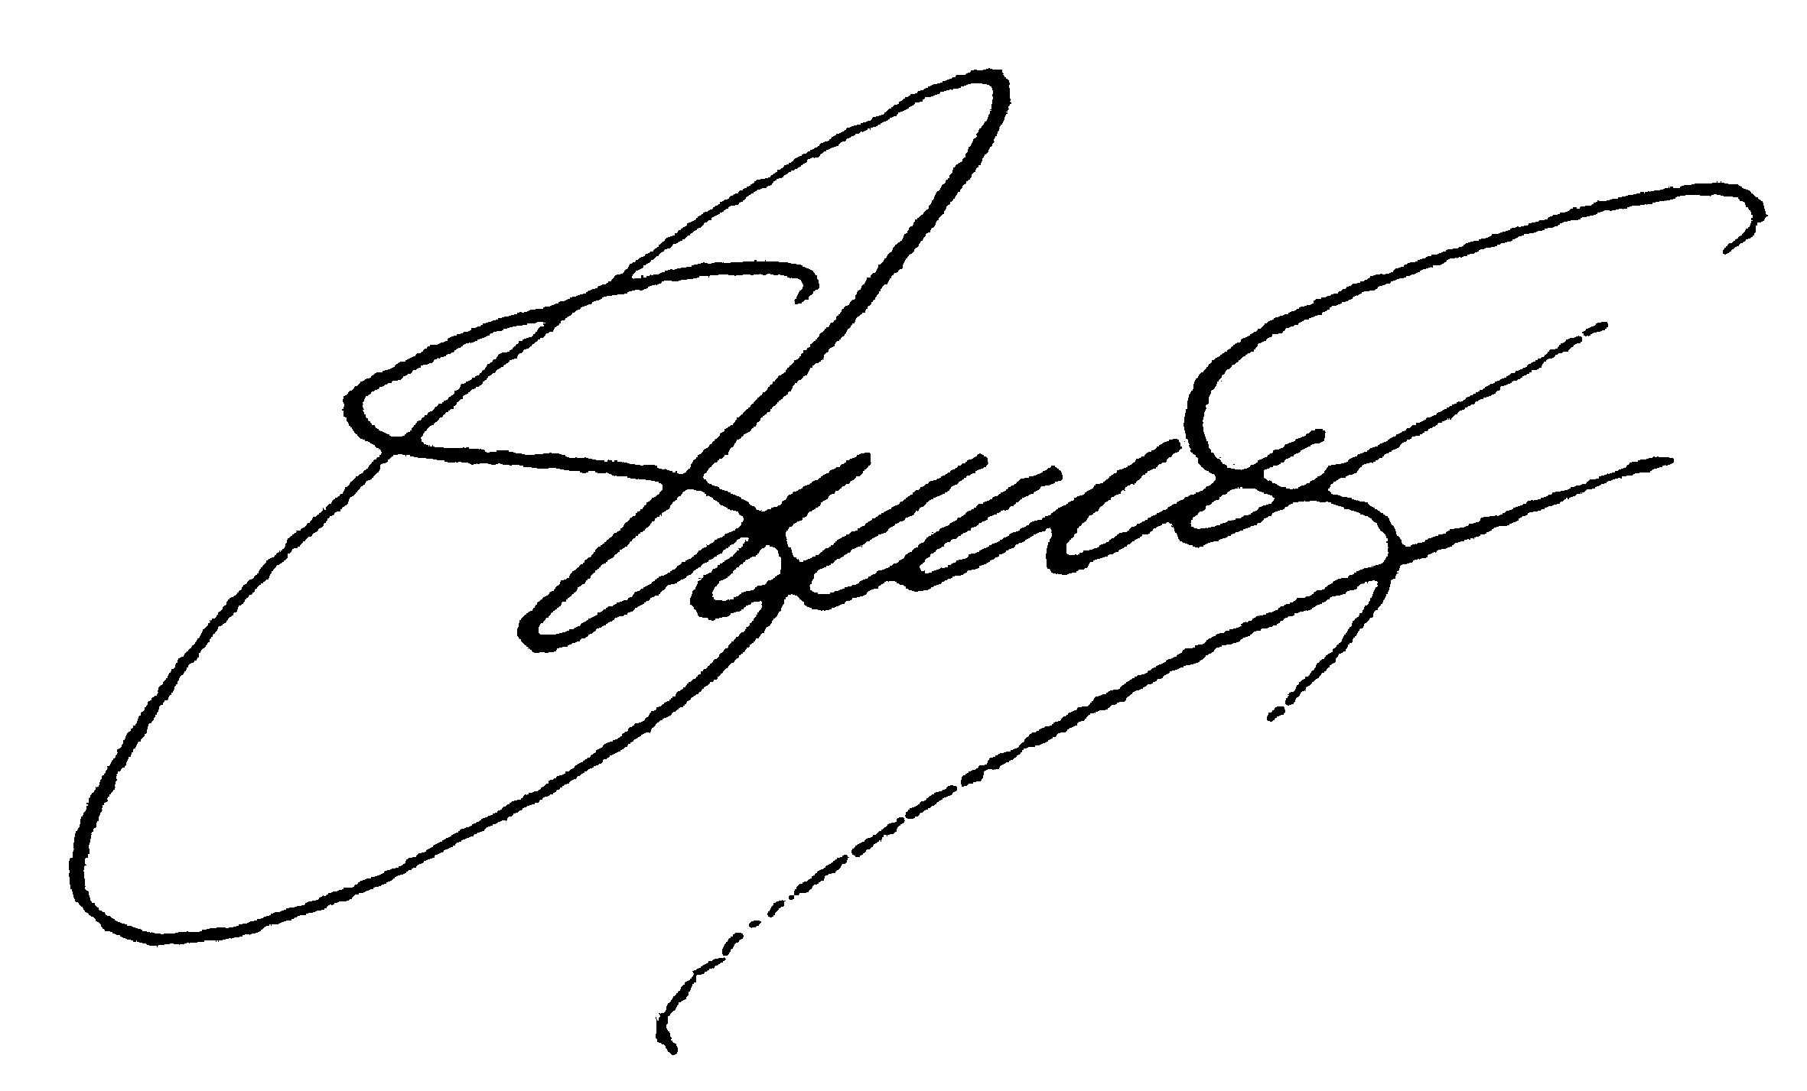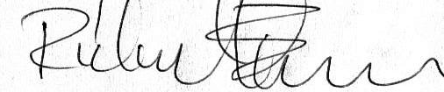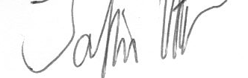
Jan Remmelg Richard Ekman Jocke Käller

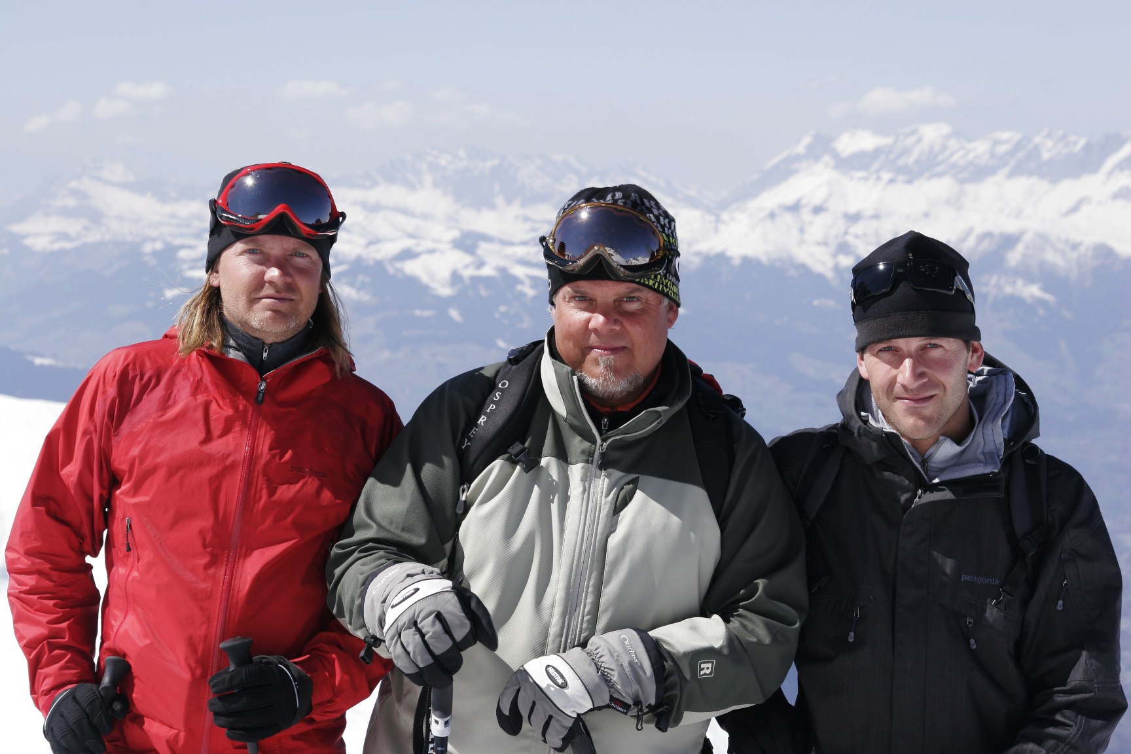

Jocke Käller Jan Remmelg Richard Ekman
Nationality: Swedish Swedish Swedish
Lives: Chamonix, France Chamonix, Fra nce Chamonix, France
Winter seasons: 12 in Chamonix 3 in Chamonix 16 in Chamonix

MAIN PARTNERS:


